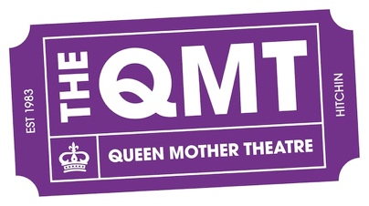

Finance Report: Summary for AGM 2025

Yearly Review:

The season of 2024 – 2025 has been a super busy season (and not yet over), with predominantly in house productions maintaining a focus on our programme pf events having made the decision to disengage with Mostly Comedy in November 2024. The only two (2) outside hires now are Hitchin Film (who also manage our NT Live programme) and Stage Tots.

We had a number of hiring enquiries, but with the additional workload to our volunteer group, we decided to remain focused on our programme and reduce the expectation to support external groups and societies this season using the premises. Both Hitchin Film and Stage Tots are self sufficient.

We have again been doing well in managing costs within our overall spend and agreed production budgets, anything else not planned for at the start of the season has had to have a budget submission for EC approval prior to purchase.

The Finance Policy was updated this season and also the finance editorial of the Directors Handbook (to manage production expense claim and the process) so we need to now make sure that everyone likely to make a claim or an expense is aware that:
- An expense sheet is required (available from Treasurer or QMT website)
- A receipt or invoice is required
- An approval is required prior to purchase (if not a Head of Dept) and anything above £250.00 needs Treasurer approval anyway

Its also important to let our departments know, that if we have an account with the supplier (you intend to purchase from), to make please we use it and also please add the min. details below:
- Their name can be as an approved reference
- The activity, play or dept is also to be used as a reference (or both if needed) so the cost can be attributed to the correct budget.

I believe the current expense sheet is suitable for use and with the legends applied the drop-down process is simple and explicit to use for any claim required. The 2025 – 2026 season expense sheet will be available from July 1st 2025.

2023/2024 accounts have been submitted to Charity Commission with no challenges or negative observations

CIO:
- CIO registration is complete and the administrators now need to be set up, but it exists as the QMT. I will review the current set up and expand to the suggested format of 4 Trustees once appointed at the AGM.
- I would suggest we do not make any changes to running or processes until after the AGM.
- The leasing agreement with the Council is now in review stage and we have will need an element of property lawyer support, who was appointed as a recommendation, approx. costs £300.00.

Production Budgets:

Current 2024/25 season is updated below tickets sales included, so far, we have had a good contributory programme with 3 shows already providing over £10k nett back to the Theatre. We still need to ensure we are managing show budgets as originally planned at the start of the season understanding some still evolve as the show starts. Our plan is still to make sure we attain an ideal percentage (%) of above 68% and above for really good contribution.

Continue to support team and department engagement is key when managing your performance budgets, the overview of course is managed by the Treasurer, PMs for Main and Studio and SMs for the production.

Below is this seasons details of productions as of Sunday 15th June

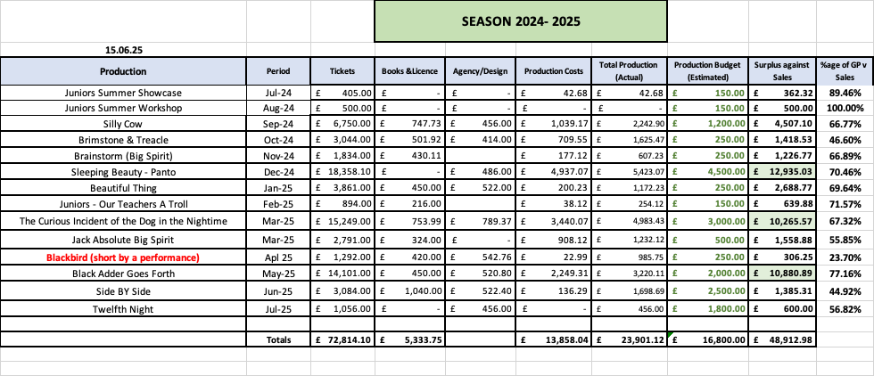

Also as usual we are looking and planning ahead, we have a season already identified for the Main and Studio productions, all licences are already purchased and it again supports our commitment to ongoing investment in the arts and the programme at the Queen Mother Theatre:

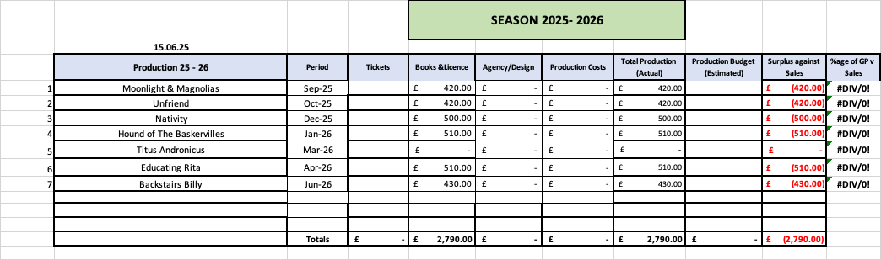

Free Cash at Bank: £1.00 - Barclays £61,510.94
** Santander has now been closed due to the disruption caused by them during the last 10 months

Mark Weatherbed
Treasurer – Queen Mother Theatre Bancroft Players

