Upon arrival, An HOUR before curtain up put on the “Front of House Manager” lanyard to be found in the lefthand cupboard in the bar area. Turn on the lights in the foyer, bar area and toilets. If appropriate, turn on the heating and lights in the foyer.
If appropriate, turn on the electric heaters in the bar areas at the wall and the ceiling heater in the foyer (using the button by the door, which is clearly labelled).
Next, check with the Stage Manager the show running time and the timings of any planned intervals. Also, who to phone when the audience is seated to start the show. Check that there is a recorded announcement before show commences - if not you will need to read an announcement in front of the seated audience – a copy of which will be supplied.
Heating/Cooling System: FoH Manager is responsible for monitoring heating and the controls are in the corridor stage left. If the weather is cold, turn up the heating when you arrive (all units showing green, 21°+, heat icon and 4 fans level - open the flaps to see). Before the audience enters Turn down to 1 fan level or off. The systems may need altering in the interval.
Check fire exits from the auditorium are clear of any obstacles & emergency exit lights on.
Familiarise yourself with the seating layout and seat numbering.
Open the external entrance door at least 45 mins before the show starts and ensure foyer glass doors are fully opened. Unlock the automatic door and turn it on. (PTO for further guidance.) Keep entrance to auditorium closed until you have checked with the Stage Manager that it is alright to allow the audience to enter.
Have a copy of the printed list of ticket purchasers ready or given to the steward in case an audience member needs reminding of their booking details. These will be emailed you in advance of the show or you will have access via a new iPad. This will also identify the empty seats should customers purchase tickets at the bar.
Phone the stage manager – using the phone behind box office, 10 minutes before the show start to alert him/her that show is due to start in 10 minutes and use the doorbell with a short ring to advise the audience still in the foyer. Be aware that you need to communicate any anticipated delays to the Stage Manager. There should also be a longer doorbell ring for the 5 minute warning prior to show start
When audience have all taken their seats confirm “go ahead” to stage manager and close the doors to the auditorium. Also, at the end of the interval if there is one, having first checked that no one is still in the toilets!
During the performance allow automatic doors to close and turn them onto exit only. During intervals they can be fully automatic or set to ‘Open’ in warm weather.
Open the auditorium doors during the interval. Check with the SM that they are ready to restart at the agreed time before using the intercom system by the phone and the doorbell above it (all behind the box office) to give the audience a 5 minute warning (Doorbell long ring) before the show is about to recommence. Check that everyone is back in and seated before giving the go ahead to the SM.
Just before the end of the show set the automatic door to ‘Open’ or automatic to allow easy exit of audience. At end of performance prop open the auditorium doors and help with an orderly exit of audience from theatre. Once the majority have left allow the automatic doors to close and lock them again.

Under usual circumstances it is the role of the Front of House manager to secure the theatre at the end of the evening, unless previously agreed with either the director or stage manager.

This involves ensuring that everyone has left the building, that all lights and heating are turned off and that all doors are closed and secure, front and backstage.

Return lanyard to the cupboard.
In the unlikely event of an emergency: If the fire alarm goes off, check quickly with the stage manager whether it is a false alarm which could have been triggered by show effects. If not, stage manager will stop the show and FoH team help with orderly exit of audience via emergency doors only not back through the Foyer. Phone 999 for emergency services.

In the event of an accident involving a member of the audience, cast or crew full details must be recorded in the Accident Book located in the pigeonhole in the main office.
A reminder that the Front of House Manager sits outside the auditorium in the Foyer during the show.

Guidance for the automatic glass entrance to the Main Theatre foyer:

- Before you touch anything above the door, please manually unlock the doors.

- Turn the switch to automatic, which allows people to enter or exit. It is best not to use other settings, as people get confused by a door that only works in one direction!

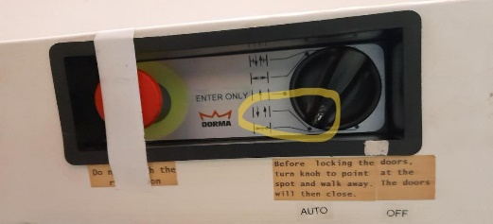

- For doors to stay open, for a speedy exit, or on a hot day set as shown right.

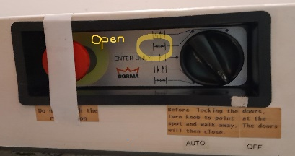

- To close the door, turn to start position and walk away. The doors will then close, so that you can manually lock the mechanical lock.

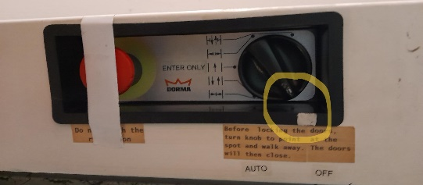

- Never press the stop button please.

Thank you.

